DELHI PUBLIC SCHOOL RAIPUR



2021-2022

HOSPITAL MANAGEMENT SYSTEM



IN PARITAL FULFILLMENT OF THE REQUIRMENT OF THE ALL-INDIA SENIOR SECONDARY CERTIFICATE EXAMINATION (AISSCE)

Roll Number : 12035

Name : Chitrarth Shrivas

Class : XII SCIENCE

Subject : Computer Science

Subject Code : 083

Guided By : Mr. Jay Karan Singh

INDEX

* CERTIFICATE
* ACKNOWLEDGEMENT
* INTRODUCTION ABOUT PYTHON
* INTRODUCTION ABOUT FILES
* INTRODUCTION OF PROJECT
* SOURCE CODE
* OUTPUTS
* FUTURE ASPECTS
* WEBLIOGRAPY
* BIBLOGRAPY

Certificate

Name : Chitrarth shrivas

Roll No. : 12035

Class : XII A

School : Delhi Public School Raipur

This is Cerified to be Bona Fide work of the student in

The Computer Science project under the guidance of Mr.

Jay Karan Singh during the Academic year 2021-22.

**Internal Examiner Principal**

**External Examiner**

ACKNOWLeDGEMENT

I would like to express my Special thanks of gratitude to my Computer Science teacher “Mr. Jay Karan Singh Sir”.

As well as our principal “Mr. Raghunath Mukherjee” who gave me the golden opportunity to do this wonderful project on the topic “**Hospital Management System**” which helped me in doing a lot of research and I came to know about so many new things. I am really thankful to them.

Secondly I would also like to thank my parents and friends who helped a lot in finalizing this project within the limited time frame.

Chitrarth Shrivas

Class – XII A

Introduction to python (front end)

Python is a widely used general-purpose, high-level programming language. It was created by Guido Van Rossum in 1991 and further developed by the Python Software Foundation. It was designed with an emphasis on code readability, and its syntax allows programmers to express their concepts in fewer lines of code.

Python is a programming language that lets you work quickly and

Integrate systems more efficiently. It uses interpreter which converts high level language (alphabets, numbers, symbols etc.) into low level language. It is used in many organizations as it supports multiple ways of programming. It also performs automatic memory management.

Python provides IDLE (i.e., Integrated Development and Learning Environment) platform to write codes in python. There are two major Python versions: Python 2 and python 3.

**Features of Python**:

* Easy to use.
* Platform independent
* It is an open-source Software
* It allows us to create varieties of operations such as:
* Programming
* Creating Web Application
* Game Development...etc...

Introduction about Files (back end)

Backend Development is the term for the behind-the-scenes activities that happens when you do anything on a website or web application. It is mostly referred to the server-side of an application and everything that communicates between the database and the frontend/ Brower. Databases are frequently used on the Backend of an application. These provides data persistence. These databases provide an interface to save data in a persistent way to memory.

We can use following types of Databases:

1. MySQL
2. SQLite
3. MongoDB
4. PostgreDB…etc.

**File Handling** is the storing of data in a file using a program. In Python programming language, the programs store results, and other data of the program to a file using file handling in Python. Also, we can extract/fetch data from a file to work with it in the program.

The operations that you can perform on a File in Python are −

* Creating a new file
* Opening an existing file
* Reading data from an existing file
* Writing data to a file
* Closing the file

Introduction about project

The concept of quality is a complex one and can mean different things to different people. For example, students and staff may differ in how they describe what quality learning and teaching means (Houston, 2007). We look at enhancing the quality at three levels: micro, meso and macro.

Assuring and enhancing the quality of learning and teaching has gained increasing prominence in recent years. Engaging in any quality assurance or enhancement process requires documenting evidence. Monitoring quality requires evidence. The focus of this course has been on gathering evidence through the processes of evaluation and reflection. “Governments, students, industry and the broader community now expect universities to provide evidence of the quality of their activities, including teaching and its contribution to successful student outcomes” (Krause, 2012, p.235).

There are two key terms requiring a clear definition:

* **Quality Assurance** – refers to the maintenance and monitoring of standards related to learning and teaching.
* **Quality enhancement** – refers to the continues improvement of learning and teaching informed by evaluation data

This project titled “**Hospital Management System**” provides for Any Hospital to replace their existing manual, paper-based system. This System targets to provide complete solution for Hospital and Health care services. This System can be used in any Hospital, Clinic, Diagnostics or Pathology labs for maintaining patient details and their test results. It Integrates the entire Resources of a Hospital into One Integrated Software Application.

Requirement of project

* HARDWARE REQUIRED:
* Ram = 512 MB
* Hard Disk = 100 MB
* Compatible Mouse / Keyboard
* SOFTWARE REQUIRED:
* Python IDLE (Version 3.7 or above)
* Windows OS
* MS Word

SOURCE CODE

import os

import pickle

import random

# New Patient Appointment.

def newpat():

rec=[]

pid=0

if os.path.isfile('HMS.dat'):

f=open('HMS.dat','rb')

rec=pickle.load(f)

f.close()

nm=input('Enter Patient\'s Name :')

age=int(input('Enter Patient\'s Age :'))

gen=input('Enter Patient\'s Gender :')

phn=int(input("Enter Phone No. :"))

add=input("Enter Patient\'s Address :")

dis=input('Enter Patient\'s Problem :')

pid=len(rec)+1

print("Your Patient's ID is : ",pid)

print('Details Successfully Registered..')

data=[pid,nm,age,gen,phn,add,dis]

rec.append(data)

a=random.randint(1,12)

d=random.randint(1,31)

e=['Jan','Feb','Mar','Apr','May']

b=random.choices(e)

c=str(d)+str(b)

print("Your Date for the appointment is :",c,"2021")

print("Your Time for the appointment is :",a,"PM")

f=open('HMS.dat','wb')

pickle.dump(rec,f)

f.close()

# New Doctor Recruitment.

def newdoc():

rec=[]

did=0

if os.path.isfile('HMS1.dat'):

f=open('HMS1.dat','rb')

rec=pickle.load(f)

f.close()

nm=input('Enter Doctor\'s Name :')

age=int(input('Enter Doctor\'s Age :'))

gen=input('Enter Doctor\'s Gender :')

phn=int(input("Enter Phone No. :"))

add=input("Enter Doctor\'s Address :")

dis=input('Enter Doctor\'s Qualification :')

did=len(rec)+1

print("Your Doctor's ID is : ",did)

print('Details Successfully Registered..')

data=[did,nm,age,gen,phn,add,dis]

rec.append(data)

a=random.randint(1,12)

d=random.randint(1,31)

e=['Jan','Feb','Mar','Apr','May']

b=random.choices(e)

c=str(d)+str(b)

print("Your Date for the Interview is :",c,"2021")

print("Your Time for the Interview is :",a,"PM")

f=open('HMS1.dat','wb')

pickle.dump(rec,f)

f.close()

# Showing Patient's Details :

def showpat():

print("1.Show All")

print("2.Search")

n=int(input("Enter Your Option : "))

if n==1:

f=open('HMS.dat','rb')

rec=pickle.load(f)

print('Patient\'s ID \t Name \t\t Age \t Gender \t Phone no. \t Address \t Disease')

print('=============================================================================')

for i in rec:

print(i[0], '\t\t' ,i[1],' \t ',i[2], '\t' ,i[3], '\t\t' ,i[4], '\t\t' ,i[5], '\t\t' ,i[6])

f.close()

elif n==2:

n=int(input("Enter Patient's ID : "))

if os.path.isfile('HMS.dat'):

found=0

f=open('HMS.dat','rb')

rec=pickle.load(f)

for i in rec:

if i[0]==n:

print('Patient\'s ID \t Name \t\t Age \t Gender \t Phone no. \t Address \t Disease')

print('=============================================================================')

print(i[0], '\t\t' ,i[1],' \t ',i[2], '\t' ,i[3], '\t\t' ,i[4], '\t\t' ,i[5], '\t\t' ,i[6])

found=1

f.close()

if found==0:

print("Record Not Found ")

else:

print("Record Does\'nt Exist")

# Showing Doctor's Details :

def showdoc():

print("1.Show All")

print("2.Search")

n=int(input("Enter Your Option : "))

if n==1:

f=open('HMS1.dat','rb')

rec=pickle.load(f)

print('Doctor\'s ID \t Name \t\t Age \t Gender \t Phone no. \t Address \t Qualification')

print('=============================================================================')

for i in rec:

print(i[0], '\t\t' ,i[1],' \t ',i[2], '\t' ,i[3], '\t\t' ,i[4], '\t\t' ,i[5], '\t\t' ,i[6])

f.close()

elif n==2:

n=int(input("Enter Doctor's ID : "))

if os.path.isfile('HMS1.dat'):

found=0

f=open('HMS1.dat','rb')

rec=pickle.load(f)

for i in rec:

if i[0]==n:

print('Doctor\'s ID \t Name \t\t Age \t Gender \t Phone no. \t Address \t Qualification')

print('=============================================================================')

print(i[0], '\t\t' ,i[1],' \t ',i[2], '\t' ,i[3], '\t\t' ,i[4], '\t\t' ,i[5], '\t\t' ,i[6])

found=1

f.close()

if found==0:

print("Record Not Found ")

else:

print("Record Does\'nt Exist")

def update():

print("1. Update Patient's Details ")

print("2. Update Doctor's Details ")

n=int(input("Enter your Option : "))

# Updating Patient's Details :

if n==1:

f=open('HMS.dat','rb')

rec=pickle.load(f)

print('Patient\'s ID \t Name \t\t Age \t Gender \t Phone no. \t Address \t Disease')

print('=============================================================================')

for i in rec:

print(i[0], '\t\t' ,i[1],' \t ',i[2], '\t' ,i[3], '\t\t' ,i[4], '\t\t' ,i[5], '\t\t' ,i[6])

f.close()

print("1. Edit 2. Delete")

m=int(input("Enter Your Option : "))

# Editing :

if m==1:

if os.path.isfile("HMS.dat"):

a=int(input("Enter Patien't ID to Edit : "))

found=0

f=open("HMS.dat",'rb')

rec=pickle.load(f)

for i in rec:

if i[0]==a:

print('Patient\'s ID \t Name \t\t Age \t Gender \t Phone no. \t Address \t Disease')

print('=============================================================================')

print(i[0], '\t\t' ,i[1],' \t ',i[2], '\t' ,i[3], '\t\t' ,i[4], '\t\t' ,i[5], '\t\t' ,i[6])

found=1

newid=int(input("Enter New patient's ID : "))

newname=input("Enter New Name : ")

newage=int(input("Enter new age : "))

newgender=input("Enter New Gender : ")

newphn=int(input("Enter New Phone No. : "))

newadd=input("Enter New Address : ")

newdis=input("Enter New Disease : ")

newData=[newid,newname,newage,newgender,newphn,newadd,newdis]

rec[a-1]=newData

print("Details Succesfully Edited..")

f.close()

f=open("HMS.dat",'wb')

pickle.dump(rec,f)

f.close()

else:

print("No records to update...")

# Deleting :

elif m==2:

if os.path.isfile("HMS.dat"):

a=int(input("Enter Patien't ID to Delete : "))

found=0

f=open("HMS.dat",'rb')

rec=pickle.load(f)

for i in rec:

if i[0]==a:

print('Patient\'s ID \t Name \t\t Age \t Gender \t Phone no. \t Address \t Disease')

print('=============================================================================')

print(i[0], '\t\t' ,i[1],' \t ',i[2], '\t' ,i[3], '\t\t' ,i[4], '\t\t' ,i[5], '\t\t' ,i[6])

found=1

rec.pop(a-1)

print("ID successfully Deleted...")

f.close()

f=open("HMS.dat",'wb')

pickle.dump(rec,f)

f.close()

else:

print("No records to Delete...")

# Updating Doctor's Details :

elif n==2:

f=open('HMS1.dat','rb')

rec=pickle.load(f)

print('Doctor\'s ID \t Name \t\t Age \t Gender \t Phone no. \t Address \t Qualification')

print('=============================================================================')

for i in rec:

print(i[0], '\t\t' ,i[1],' \t ',i[2], '\t' ,i[3], '\t\t' ,i[4], '\t\t' ,i[5], '\t\t' ,i[6])

f.close()

print("1. Edit 2. Delete")

m=int(input("Enter Your Option : "))

# Editing :

if m==1:

if os.path.isfile("HMS1.dat"):

a=int(input("Enter Doctor's ID to Edit : "))

found=0

f=open("HMS1.dat",'rb')

rec=pickle.load(f)

for i in rec:

if i[0]==a:

print('Doctor\'s ID \t Name \t\t Age \t Gender \t Phone no. \t Address \t Qualification')

print('=============================================================================')

print(i[0], '\t\t' ,i[1],' \t ',i[2], '\t' ,i[3], '\t\t' ,i[4], '\t\t' ,i[5], '\t\t' ,i[6])

found=1

newid=int(input("Enter New Doctor's Id : "))

newname=input("Enter New Name : ")

newage=int(input("Enter new age : "))

newgender=input("Enter New Gender : ")

newphn=int(input("Enter New Phone No. : "))

newadd=input("Enter New Address : ")

newqua=input("Enter New Qualification : ")

newData=[newid,newname,newage,newgender,newphn,newadd,newqua]

rec[a-1]=newData

print("Details Succesfully Edited..")

f.close()

f=open("HMS1.dat",'wb')

pickle.dump(rec,f)

f.close()

else:

print("No records to update...")

# Deleting :

elif m==2:

if os.path.isfile("HMS1.dat"):

a=int(input("Enter Doctor's ID to Delete : "))

found=0

f=open("HMS1.dat",'rb')

rec=pickle.load(f)

for i in rec:

if i[0]==a:

print('Doctor\'s ID \t Name \t\t Age \t Gender \t Phone no. \t Address \t Qualification')

print('=============================================================================')

print(i[0], '\t\t' ,i[1],' \t ',i[2], '\t' ,i[3], '\t\t' ,i[4], '\t\t' ,i[5], '\t\t' ,i[6])

found=1

rec.pop(a-1)

print("ID successfully Deleted...")

f.close()

f=open("HMS1.dat",'wb')

pickle.dump(rec,f)

f.close()

else:

print("No records to Delete...")

def Exit():

print("*=====*=====*====May God Bless You======*======*=====*")

exit(0)

# Menus

while True:

print('\t\t===============================')

print('\t\t\tWelcome To City Hospital')

print('\t\t===============================')

print('\t\t\t\tMenu')

print('1. New Patient Appointment')

print('2. New Doctor Recruitment')

print("3. Show Patient's Details")

print("4. Show Doctor's Details")

print('5. Update Record')

print('6. Exit')

n=int(input('Enter your Option :'))

if n==1:

newpat()

if n==2:

newdoc()

if n==3:

showpat()

if n==4:

showdoc()

if n==5:

update()

if n==6:

Exit()

Outputs

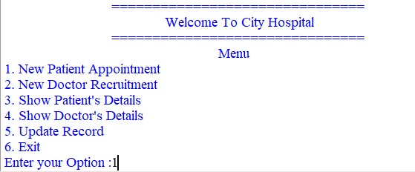

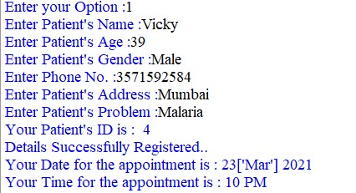

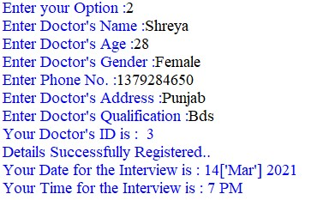

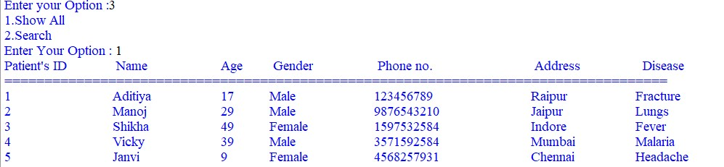

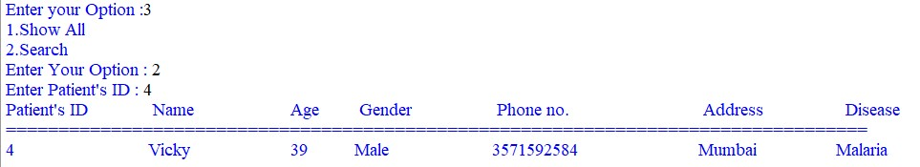

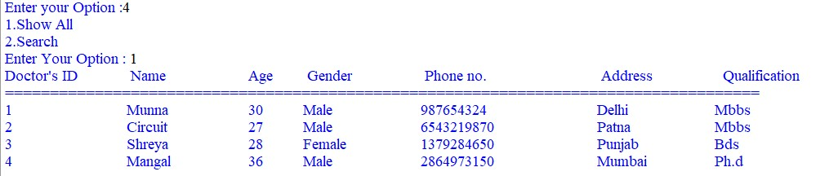

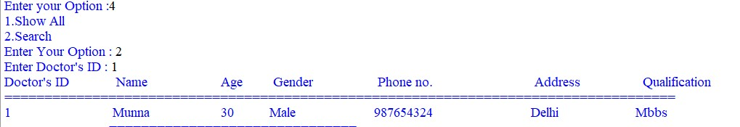

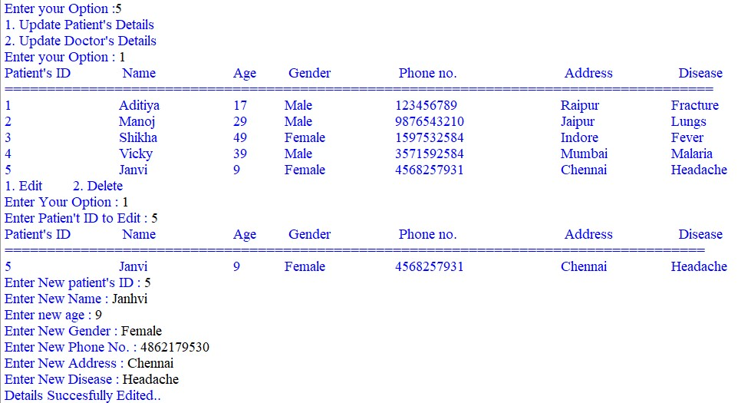

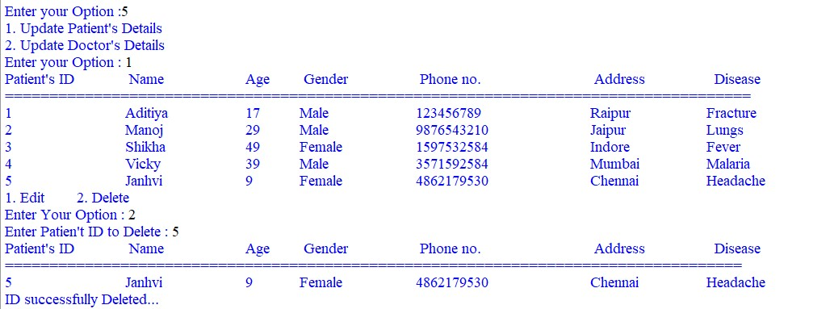

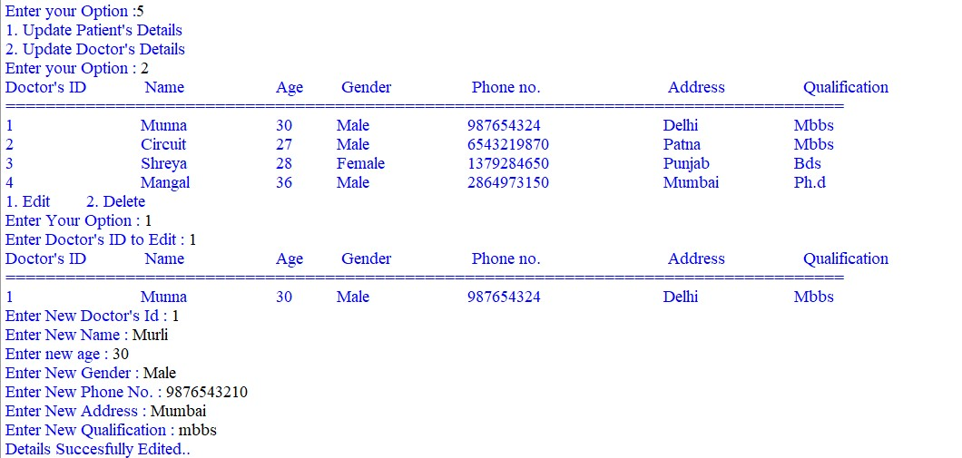

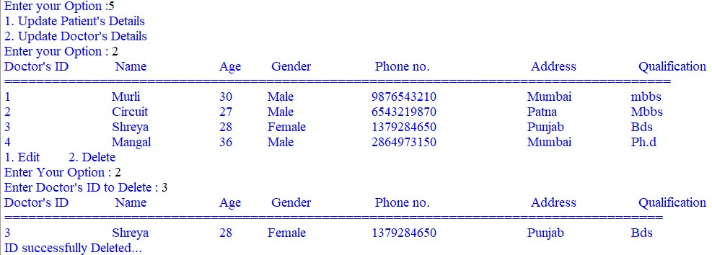

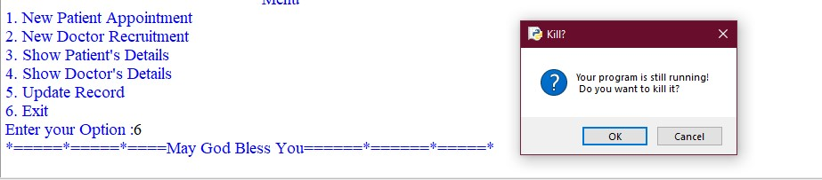

Future aspects

1. Network Support System.
2. Counselling with Patients.
3. We can add some graphics.
4. We can add online Payment system.
5. Adding facilities like Pharmacy System for the stock details of medicines in the Pharmacy.
6. Adding Details of the Workers working in the Hospital.

Bibliography

* Computer Science with Python

By – Sumita Arora

Webliography

* www.google.com
* www.python.org
* www.wikipedia.com
* www.geeksforgeeks.com
* www.w3resource.com